Table of Contents
1 Observables 1
1.1 Basic Observables 1
1.2 Computed Observables 1
1.3 Observable Arrays 2
1.3.1 Observable array functions. 2
2 Resources 1

Observables

Basic Observables
Properties of ViewModel set to 'observable' (ko.observable).
$(function(){
var theViewModel = {
name: ko.observable("booby"),
changeName: function(){
this.name("yay");
}
};
ko.applyBindings(theViewModel);
});

Computed Observables
Take a function as argument.
$(function() {
var viewModel = {
name: ko.observable("Bob"),
changeName: function() {
this.name("Steve");
},
nameVisible: ko.observable(true)
};

viewModel.displayName = ko.computed(function(){
return this.name() + ' is' + (!this.nameVisible() ? ' not':'') + ' visible';
},viewModel);

ko.applyBindings(viewModel);
});

Observable Arrays

Observable array functions.
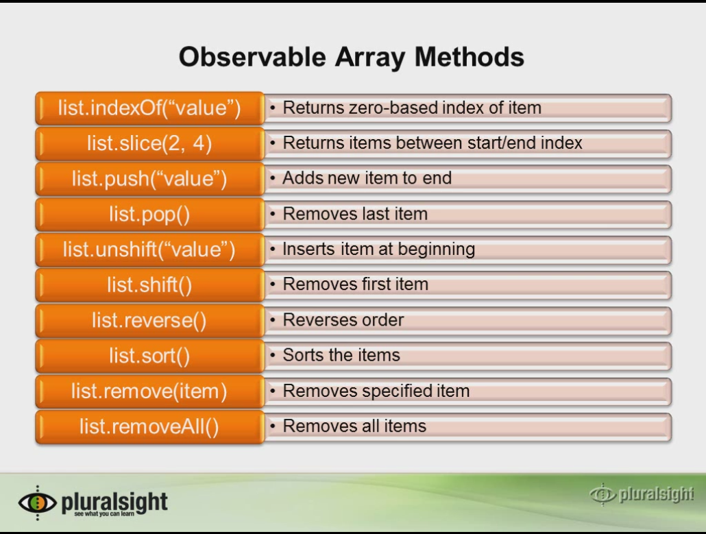

Resources
http://Knockoutjs.com
http://blog.stevensanderson.com
http://www.knockmeout.net

